Food delivery has become an indispensable aspect of modern-day living. A recent survey by Mintel, indicates that a significant portion of the American population, approximately one-third, orders food online no less than twice per week (Hendelmann, 2023). It is estimated that by 2024, the global food delivery market will be valued at $182.3 billion (Spdload, 2023).

Food delivery refers to a type of courier service where meals or food items are transported from stores, restaurants, or third-party applications to customers who have placed orders and require delivery on an immediate or scheduled basis (Hendelmann, 2023). The earliest documented case of food delivery happened in Italy in 1889 when Raffaele Esposito, the inventor of Pizza Margherita, was summoned by King Umberto and Queen Margherita to deliver a pizza to their palace in Naples (history of food delivery 2021). Since then, the food delivery system has risen and expanded globally due to a combination of technological advancements, changing consumer habits, and the need for convenience and accessibility.

In a food delivery system, there are typically three parties involved.

1. The customer/ person ordering
2. The delivery agent
3. The restaurant where the order is placed





In broader terms, below is the overview of how the model works or its operations:



* **Customer Order Placement**: Customers place their food orders through a mobile app or website, they browse through the available restaurant options selecting their preferred restaurant, menu items, and delivery address. They would finally review the details of their selection on the checkout page. On the checkout page, they will then set the tip amount, payment method, delivery address, order delivery time, and if there is a promotion they wish to apply to their order.
* **Restaurant Preparation**: Upon confirmation of payment, the restaurant receives the order and prepares the food, packaging it for delivery.
* **Delivery Dispatch**: The delivery service matches available drivers in the area to the order, dispatches a delivery driver to pick up the food from the restaurant and deliver it to the customer.
* **Delivery**: The delivery driver transports the food to the customer, following the optimized route provided to him/her by the delivery service's dispatch system.
* **Payment**: The customer pays for the food, delivery fee, obtains a discount (if available) and any other applicable charges through the delivery service's mobile app or website. The customer payment details are verified prior to finalizing the order. The delivery service also pays the restaurant for the cost of the food and takes a commission for facilitating the transaction. The food delivery intermediary or service also pays the driver for the delivery of food.

**Online Food Ordering System ER Diagram**

The ER Diagram for O nline Food Ordering System illustrates the entity relationships between each entity.

**ENTITIES AND THEIR RELATIONSHIP**

**Entities in the Model:**

The Food Delivery System’s Model shall consist of the following entities.

1. **Customer**: This entity would represent the customers who use the online food delivery service to order food from restaurants. Primary key for this entity will be CustomerID.
2. **Restaurant:** This entity would represent the restaurants that provide food to customers through the online food delivery service. Primary key for this entity will be RestaurantID.
3. **Menu Item:** This entity would represent the different items available on the menus of restaurants. Primary key for this entity will be MenuID.
4. **Order:** This entity would represent the orders placed by customers for food items from restaurants. Primary key for this entity will be OrderID.
5. **Delivery Agent:** This entity would represent the agents responsible for delivering food items to customers. Primary key for this entity will be DriverID.
6. **Payment:** This entity would represent the payments made by customers for their food orders. Primary key for this entity will be PaymentID.
7. **Address:** This entity would represent the delivery addresses of customers. Primary key for this entity will be AddressID.

**Relationship and Cardinality Between the Entities:**

These entities can be related to each other in the following ways:

* A customer can place multiple orders and an order can be placed by a single customer. This is a one-to-many relationship.
* A restaurant can have multiple menu items and a menu item can belong to only one restaurant. This is a one-to-many relationship.
* An order can consist of multiple menu items and a menu item can be a part of multiple orders. This is a many-to-many relationship and can be resolved by creating a new entity, Order Item, to represent the relationship between Orders and Menu Items with a composite Primary Key of OrderID and MenuID.
* An order can be placed for a single delivery address and a delivery address can receive multiple orders. This is a one-to-many relationship.
* An order can be paid for using a single payment and a payment can be used to pay for multiple orders. This is a one-to-many relationship.
* An order can be delivered by a single delivery agent and a delivery agent can deliver multiple orders. This is a one-to-many relationship.

**ER Diagram to Logical Schema Conversion:**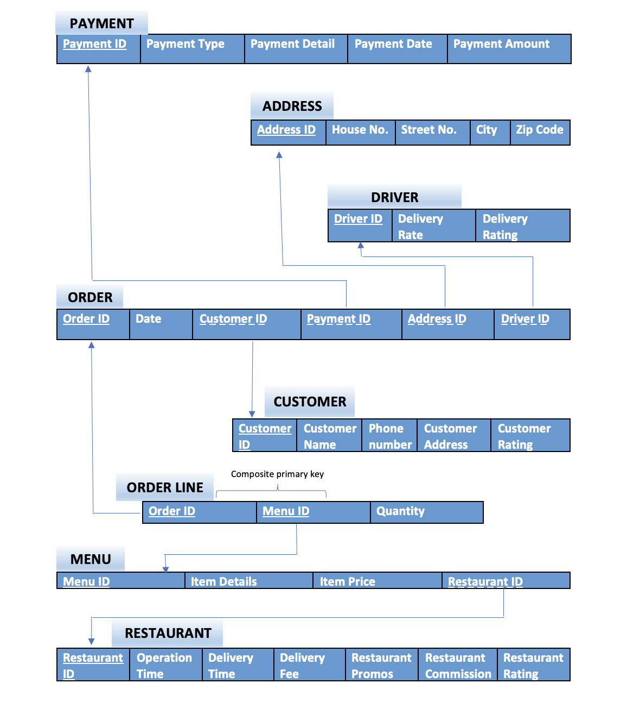

The above Logical Schema conforms to the ***3rd Normal Form***.

* All the database tables have atomic attributes. There are no columns in any of the tables with multiple values. Hence, the condition for the 1st Normal Form is satisfied.
* All the database tables do not have partial dependency. All columns have full functional dependencies. Hence, the condition for the 2nd Normal Form is satisfied.
* All the database tables do not have transitive dependency. Hence, all the conditions for the 3rd Normal Form are satisfied.

MYSQL codes and Queries

**Bibliography:**

*[1] grubtech (Ed.). (2021, March 8). How did food delivery start? history of food delivery. How did food delivery start? History of food delivery. Retrieved February 13, 2023, from https://blog.grubtech.com/history-of-food-delivery*

*[2] Hendelmann, V. (2023, January 2). The Food Delivery Business Model – A Complete Guide. productmint. Retrieved February 13, 2023, from https://productmint.com/the-food-delivery-business-model-a-complete-guide/*

*[3] Spdload. (2023, February 9). Food Delivery Business Model 101 for founders. SpdLoad. Retrieved February 13, 2023, from https://spdload.com/blog/food-delivery-business-model/*